2nd Annual Nordic Cilia and Centrosome
Network Meeting

Hankø, Norway
April 23rd-25th - 2012

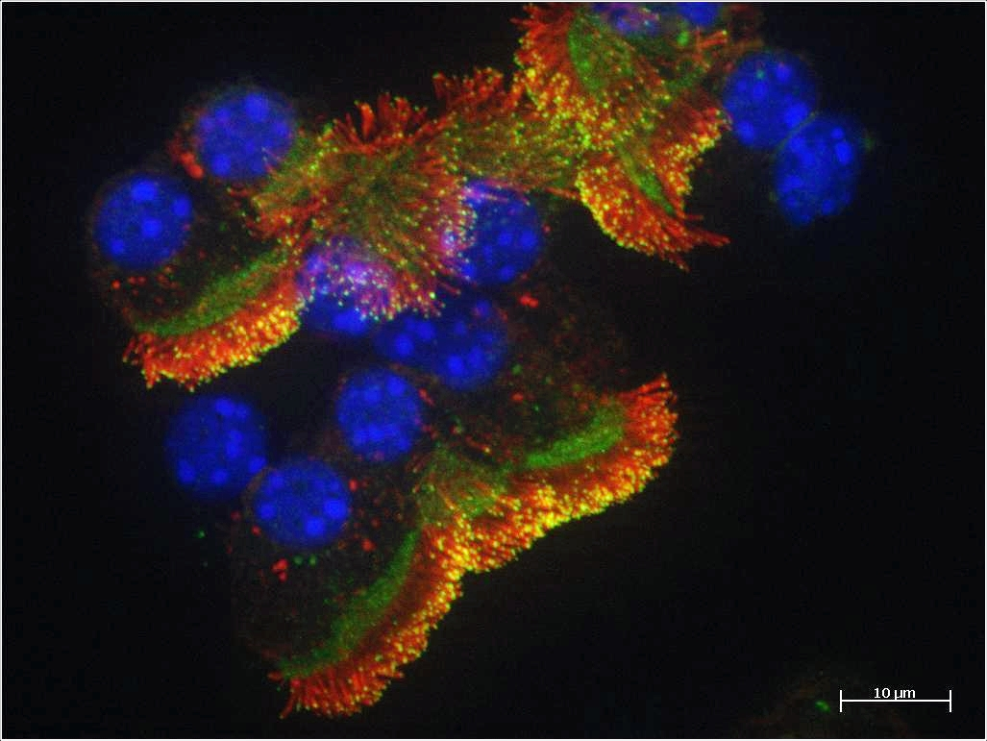

Preliminary Program

Keynote Lectures

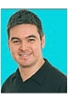
Philip L Beales
University College London
Institute of Child Health

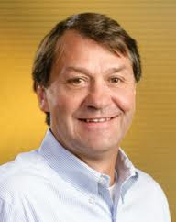
Stephen J Doxsey
University of Massachusetts Medical School
Program in Molecular Medicine

Confirmed Network Member Presentations:

Lotte B Pedersen
University of Copenhagen – Department of Biology
Søren T Christensen
University of Copenhagen – Department of Biology
Harald Stenmark
OUH Norwegian Radium Hospital – Institute for Cancer Research
Sebastian Patzke
OUH Norwegian Radium Hospital – Institute for Cancer Research

Monday, 23.4.2012

Bus leaving from OSL at 14.00, estimated arrival at Hankø around 16.00

Check-in

16.00-17.30 Coffee & Fruit
17.30-17.50 Welcome note, Network update/overview of participants
18.00-19.00 Keynote 1:
Philip L Beales (40+5 min)
“Title to come”
19:00-20.00 Dinner
20.00-20.50 Presentations by Network Members (20+5 min):
Lab
"Talk selected from submitted abstracts"
Lab
"Talk selected from submitted abstracts"
20.50- Unattended Poster Session & Social Gathering

Tuesday, 24.4.2012

Breakfast
09.00-10.40 Presentations by Network Members (20+5min):
Lab
"Talk selected from submitted abstracts"
Lab
"Talk selected from submitted abstracts"
Lab
"Talk selected from submitted abstracts"
Lab
"Talk selected from submitted abstracts"
10.40-11.00 Coffee Break
11.00-12.00 Keynote 2:
Stephen J Doxsey (40+5 min)
“Title to come”
12.15-13.15 Lunch

13.15-16.00 Poster Session & free time
(presenters should stay at poster from 13.15-14.30)
16.00-17.00 Coffee Break w/Cake & Fruits
17.00-18:40 Presentations by Network Members (20+5min):
Lab
"Talk selected from submitted abstracts"
Lab
"Talk selected from submitted abstracts"
Lab
"Talk selected from submitted abstracts"
Lab
"Talk selected from submitted abstracts"
19:00-20.00 Dinner & Presentation of Poster Awards
20.00 Social Gathering / Entertainment
Wednesday, 25.4.2012

Breakfast & Check-out (before 11.00)
09.30-11.10 Presentations by Network Members (20+5min):
Lab
"Talk selected from submitted abstracts"
Lab
"Talk selected from submitted abstracts"
Lab
"Talk selected from submitted abstracts"
Lab
"Talk selected from submitted abstracts"
11.10-11.30 Closing Remarks
11.30-12.00 Steering Group Meeting
12.00-13.00 Lunch

Departure: bus from Hankø leaving at 13.30, estimated arrival at OSL around 15.30

